# IT 140 Design Document Template

Jacob Whetham

SNHU | Troy Goldie

IT140

July 30, 2022

## Instructions

Fill out the sections below. Be sure to remove the bracketed text before submitting your Design Document.

## Storyboard (Description and Map)

You awaken in a dungeon having little memory of what brought you there. A robotic being missing its legs rest in the corner of the cell. The robot takes notice of you and introduces itself. He is Mack Guy Ver-1, an unhappy former servant of the lord of the manor. He tells you of the horrors that occurred which led to you being imprisoned. Mack Guy Ver-1 instructs you that the lord of the manor must be stopped by any means necessary to earn your freedom and prevent further atrocities from taking place. The servant bends the cell bars to let you out before giving you a list of materials you need to defeat the lord of the manor:

* The pantry key from a bowl sitting on a pedestal in the foyer.
* A feather from the lord’s prized parakeet in the dining room.
* A sack of potatoes from inside the pantry.
* A vial of water from the kitchen.
* A shoelace from a pair of old boots in a closet west of the foyer.
* The elevator key from the wine cellar.

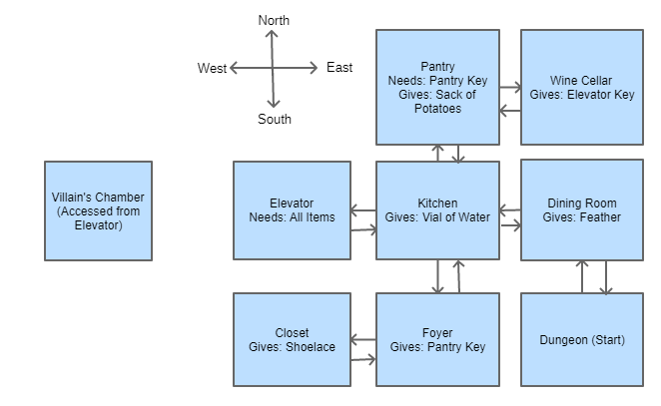

## Movement Psuedocode:

WHILE true (infinite loop):

GET user input

IF user input is a valid direction (e.g. south):

IF user can move in that direction (not a wall):

UPDATE player’s position

LOAD room relating to player position

PROVIDE prompt for that room

CONTINUE (restart loop)

ELSE IF user cannot move in that direction (not a doorway):

OUTPUT error to user

CONTINUE (restart loop)

ELSE (input is not a direction):

PERFORM necessary operation (take item, quit game, output error, etc)

## Inventory Psuedocode:

WHILE true (infinite loop):

GET user input

IF user input is for taking item (e.g. input starts with “take”):

IF item is still available:

ADD item to player’s inventory

ADD item to “taken” list

OUTPUT success to playerCONTINUE (restart loop)

ELSE (Item was already taken, invalid item, etc):

OUTPUT error to playerCONTINUE (restart loop)

ELSE (input is not for taking an item):

PERFORM necessary operation (move player, quit game, output error, etc)